Session 3 -1
import java.io.*;
class Result {
public static String timeConversion(String s) {
String ampm = s.substring(s.length() - 2);

int hour = Integer.parseInt(s.substring(0, 2));
String minSec = s.substring(2, s.length() - 2);

if (ampm.equals("PM")) {
if (hour != 12) {
hour += 12;
}
} else { // AM case
if (hour == 12) {
hour = 0;
}
}

return String.format("%02d", hour) + minSec;
}
}
public class Solution {
public static void main(String[] args) throws IOException {
BufferedReader bufferedReader = new BufferedReader(new InputStreamReader(System.in));
BufferedWriter bufferedWriter = new BufferedWriter(new FileWriter(System.getenv("OUTPUT_PATH")));
String s = bufferedReader.readLine();
String result = Result.timeConversion(s);
bufferedWriter.write(result);
bufferedWriter.newLine();
bufferedReader.close();
bufferedWriter.close();
}
}
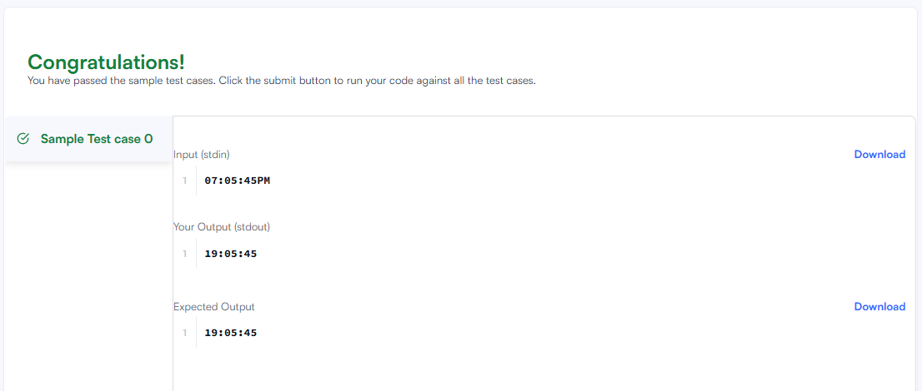

Session 3 - 2
public void moveZeroes(int[] nums) {
int lastNonZeroFoundAt = 0;

for (int cur = 0; cur < nums.length; cur++) {
if (nums[cur] != 0) {
int temp = nums[lastNonZeroFoundAt];
nums[lastNonZeroFoundAt] = nums[cur];
nums[cur] = temp;

lastNonZeroFoundAt++;
}
}
}
}

